assignment #01

Course: CHE 341: Chemical Process Control
Term: Spring 2026
Professor: Dr. Michael Caracotsios
Office: EIB 244

Cell Phone: (630) 696-0934
E-mail: mcaracot@uic.edu

Name: __________________________________________
Due Date: Friday, January 23rd TA’s Mailbox by 3:00PM

INSTRUCTIONS FOR ASSIGNMENT DELIVERY

- Prepare a typed report of your assignment.
- Include this cover page with your name(s) in the report.
- Upload your report as a PDF file by the Due Date and Time on the UIC Blackboard.
- Place a hard copy of your report as a PDF file by the Due Date and Time in the TA’s mailbox.

- Assignments that are not typed will not be accepted.
- Late Assignments will not be accepted without prior approval.
- You may use the Internet as well as ChatGPT or other public tools as long as you place a written statement about their use in your assignment report

Problem A: Modeling of a Blanketed Storage Tank for Methanol

A well-insulated cylindrical tank (see Figure below) is used for storage of liquid methanol. The tank has volume of and the surface area of the bottom is . The liquid methanol is blanketed with nitrogen to avoid contamination with air and moisture. The feed and effluent line valve coefficients are . The valves exhibit linear characteristics and the flow rate through the valves is given by the equations

where is the specific gravity of methanol. The gauge pressure in the tank (measured in the nitrogen space) is and the temperature . The upstream to the feed line valve pressure is and the downstream to the effluent line valve pressure is .

Figure: Methanol Storage Tank

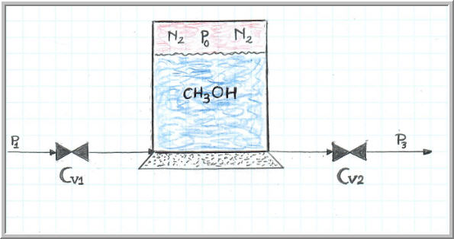
Develop the necessary equation(s) required to monitor the liquid methanol height and the temperature of the vapor space as a function of time, due to various pressure disturbances in the feed and effluent lines. After you develop the model perform the following tasks

- Calculate the steady-state liquid methanol height in ft
- Calculate the number of moles of methanol and nitrogen in the vapor space
- Perform a dynamic simulation for about 4 hr to demonstrate that the liquid height and temperature remain constant at the steady-state values in the absence of any disturbances
- Start the simulation again at t=0min. At time t=2 hr, the upstream to the feed valve pressure increases by 20%. Plot the liquid height and vapor space temperature as a function of time and calculate the new steady-state values.
- Calculate the final pressure in psia of the vapor space in the storage tank
- Calculate the time, in min, required to reach the new steady-state values defined as 99.5% of the asymptotic (steady-state) values.
- In one Appendix of your report include all the plots of your analysis.
- In a second Appendix of your report include the computer code with all the data that you used to do the numerical integration. You are free to use any software (like Matlab) but I would strongly recommend that you use the CHE Calculator

Data and Assumptions:

- You may get the methanol and nitrogen properties from the ASPEN Plus simulator or the CHE Calculator (I would recommend the CHE Calculator)
- Assume that nitrogen/methanol mixture in the vapor space behaves as an ideal gas with constant heat capacities .
- Assume that the amount of methanol in the vapor space does not change appreciably because of temperature and pressure variations.

Problem B: Design vs. Operational Models: Understanding Positive Feedback

Consider the ASPEN Plus simulation file that is uploaded on the UIC Blackboard along with your first assignment. The simulation file describes the catalytic oxidation of a hydrocarbon in n adiabatic fixed bed reactor. The feed to the reactor is preheated to a temperature of 310 ºC using a CFE (Combined Feed Exchanger) as shown in the diagram below:

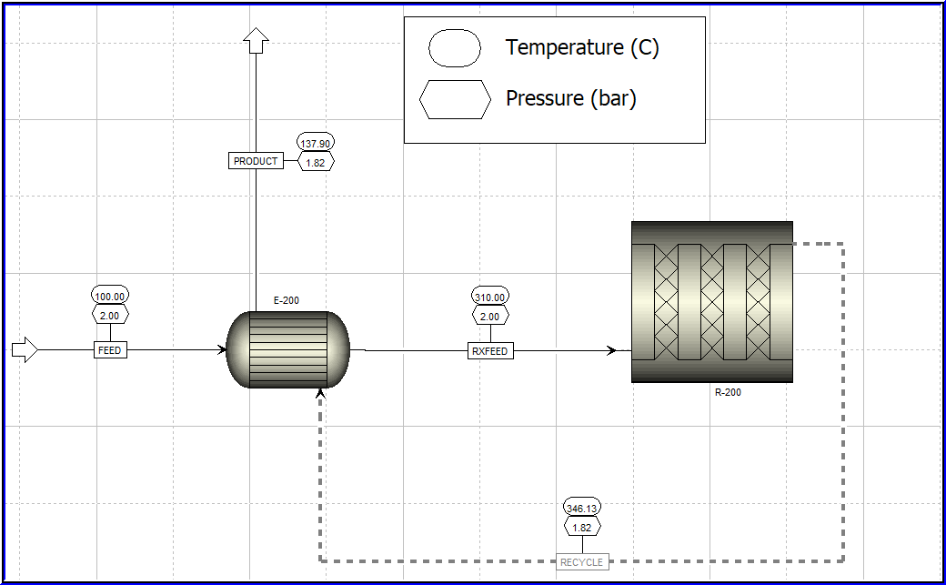

Perform the following tasks:

- Study the simulation file and provide a description (no longer than one page) of what this design is all about with some detail on the reaction mechanism and the reactor design.
- Modify the simulation file to reflect operational mode. The current one is the design mode.
- Determine what will happen if due to some unforeseen disturbances the reactor effluent temperature increases by 2 ºC. When answering this question assume that there are no controls in place. Describe in detail you answer and corroborate it with the proper simulations. Assuming that it takes 20 seconds for the disturbance to go through the process, plot the temperature of the reactor effluent versus time for the first 60 seconds after the onset of the disturbance
- Recommend a solution to remedy the situation resulting from the unexpected rise in temperature and modify the simulation file to reflect your recommendation. Describe in detail your recommendation and report the results of your simulation that reflect your recommendation. Also calculate the net increase or decrease in utilities after the onset of the disturbance.

